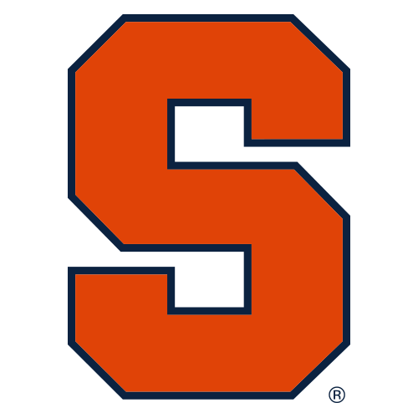

Syracuse University Athletics

**FOR IMMEDIATE RELEASE**

**DATE: October 8, 2019**

**CONTACT: Daniel Loftus,** [**dploftus@syr.edu**](mailto:dploftus@syr.edu) **(315) 443-3232**

**SU Athletics Announces Teams to be Featured in Inaugural**

**Dave Bing Classic**

*A total of four projected top-25 teams are set to visit newly renovated Dome*

**SYRACUSE, N.Y.** – The Syracuse University men’s and women’s basketball teams have announced the eight opponents set to square off in the newly renovated *Carrier Dome* as part of the first-annual *Dave Bing Classic* slated for the weekend of Oct. 28-30, 2022. The round-robin style tournament will feature Gonzaga, Michigan State, Detroit Mercy, and Syracuse on the men’s side. Meanwhile, the women’s tournament hosted by SU features UConn, Xavier, and Maryland.

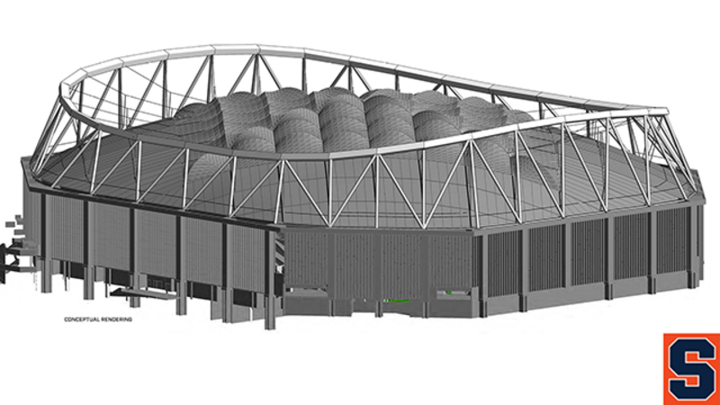

“The teams selected were critically chosen to foster the best on-court product while also honoring the legacy of Dave Bing,” said *John Wildhack,* SU Director of Athletics. “This is a special event for the whole university community, as we unveil the newly renovated Dome and welcome Dave [Bing] back to campus. We wanted this tournament to be something special, and I believe the teams slated to compete will provide just that.”

Gonzaga and Michigan State for the men and UConn and Maryland on the women’s side all finished last season ranked in the top-25, and they are projected to hold high rankings at the beginning of the tournament. Detroit Mercy, which is located in the city where Dave Bing was mayor for 12 years, rounds out the men’s bracket. Xavier University under first-year head coach Melanie Moore will play on the women’s bracket. The Syracuse men’s basketball team, led by guard *Buddy Boeheim*, and women’s basketball team, led by honorable mention All-American guard *Tiana Mangakahia*, are both projected NCAA Tournament teams and are set to begin the year ranked in the AP Top-25.

“Getting to honor my former roommate in a tournament while also allowing my team to play against the best in the country is a no-brainer for me,” said *Jim Boeheim*, Syracuse men’s basketball coach and college roommate of Dave Bing. Bing and Boeheim played together for the Orange from 1963-66.

The Carrier Dome recently underwent a $205 million renovation to implement a new permanent roof, add air conditioning units, and other fan experience improvements. The Dave Bing Classic will be the first Syracuse University Athletic event to be hosted in the Dome following the improvements.

Season tickets are now on sale for Syracuse men’s and women’s basketball. Packages start for under $100, and tickets for the Dave Bing Classic, season tickets, and individual game tickets can be purchased HERE.

*The Syracuse University Athletic Department is the overseer of the 18 NCAA Division I athletic programs proudly supported by the Syracuse University. Our mission as an organization is to “create and foster a culture of academic and athletic excellence which prepares student-athletes as leaders in our global society.”*